**COMPUTER NETWORKS PRACTICAL EXAM OUTPUT (SET-1)**

Name: Ritika Sharma

Roll Number: 20201454

Examination Roll Number: 20016570017

Course Name: BSC Honors Computer Science

Output 1:

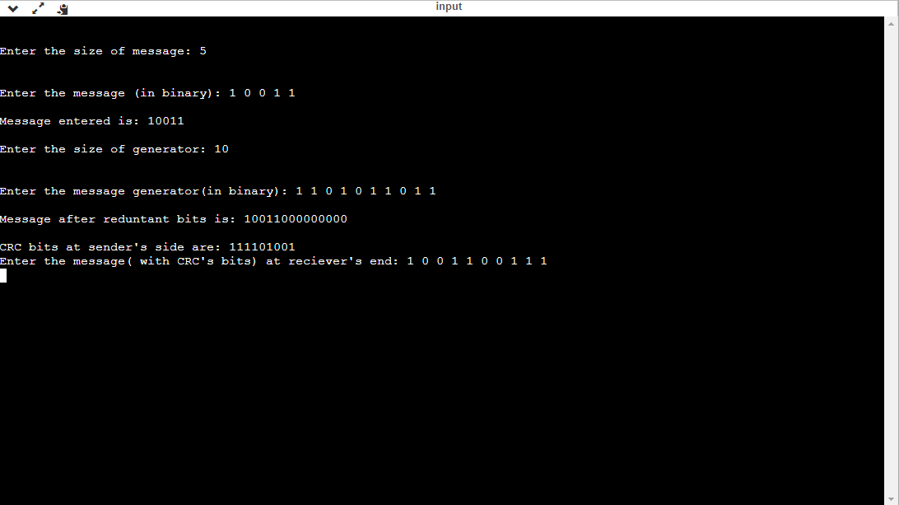

Output 2:

